------------------------------------------------------------------------------------------------------------------

**set up a VPC with an Internet gateway, create a public subnet, a private subnet make a route table connecting the Internet gateway and the subnets, and launch a Linux EC2 instance by using the above vpc and public subnet.**

**> set up a VPC with an Internet gateway**

**VPC name > Mytask**

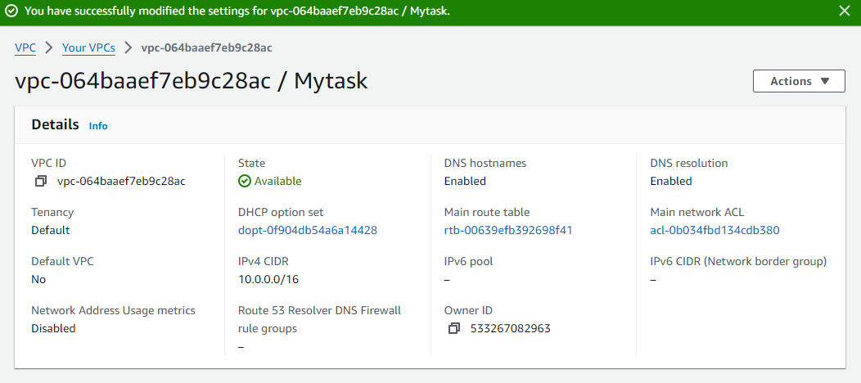IG attached to created VPC

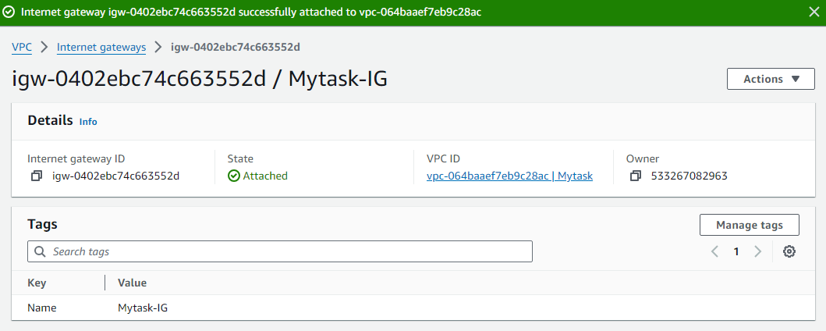

> **created a public subnet, a private subnet**

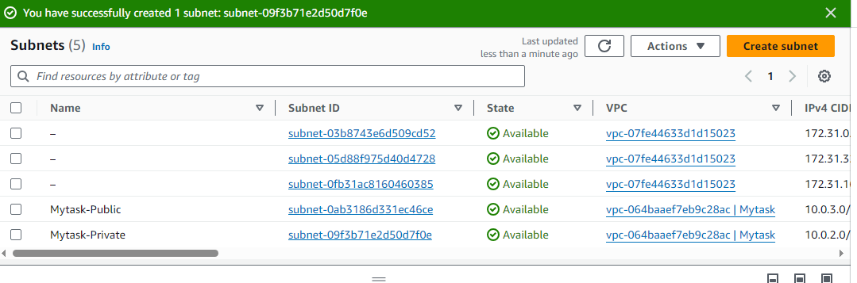> **making a route table connecting the Internet gateway and the subnets**

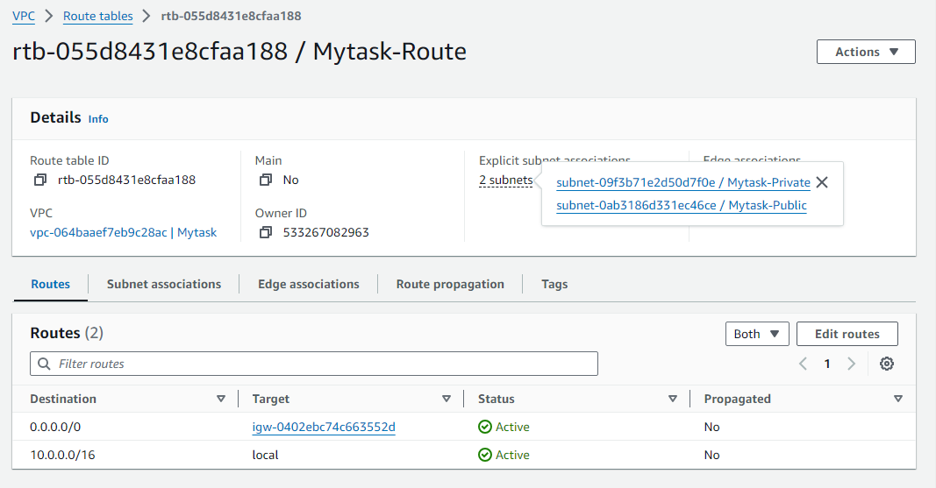

> **launch a Linux EC2 instance by using the above vpc and public subnet.**

